Radwa Kamal, BSc.
Address: Giza, Egypt
Number: 01032859950
Email: radwa.kamal1@msa.edu.eg
LinkedIn profile: http://www.linkedin.com/in/radwa-kamal-b64b09277

Research Interest

Research assistant with a strong interest in molecular genetics and biotechnology as a foundation for improving human health and sustainability. I am also interested in exploring how biotechnology can be applied in biochemical engineering to create solutions that support environmental protection. To connect science with real-world use, I integrate tools in my lab such as programming, artificial intelligence, Robotics, 3D designing, and high-performance computing (HPC) for large-scale data processing, model training, and scientific analysis. I hope to grow within a research-focused academic environment where I can build this interdisciplinary approach and address challenges at the intersection of biology, technology, and sustainability.
Education

September 2022 – June 2026: B.Sc., Faculty of Biotechnology., MSA University, Cairo, Egypt.

- GPA: 3.53
- Graduation project 1: Humanoid Robodoc: An AI-Driven Humanoid Robot for Patient Diagnosis and Care Assistance
Grade: A
- Graduation project 2: Loopet: Autonomous Bioconversion of Poultry Waste into Certified Functional Feed Using an AI-Controlled Thermal Processing System and Automated Material Handling in Egypt
Grade: A

September 2022 – June 2026: B.Sc., School of Science., University of Greenwich, London, UK.
- GPA: 3.6
Coursework

Programming & AI
- Artificial Intelligence
- Bioinformatics
- Basic Programming
Plant & Agricultural Foundations
- Botany
- Plant Cell & Tissue Culture
Molecular & Genetic Sciences
- Molecular Biology
- Molecular Genetics
- Advanced Genetics
- Complex Genomes
- Proteomics
Data & Analytical Sciences
- Biostatistics
- Instrumentation
- Biochemical Engineering

Experience

Apr 2024 - present: Undergraduate Research assistant - Prototyping Research Lab., MSA University., Egypt.

Designing and optimizing devices using 3D modeling software including Blender

Applying Python programming for AI-based analysis and automation

Developed machine learning models for image-based biomarker detection

Conducted system integration between hardware, sensors, and AI algorithms
Awards & Events

- Honored as the Top Achiever of the Faculty of Biotechnology by the Dean during the official University Ceremony, in recognition of achieving the highest number of competition wins and awards among the faculty's students.
- 2nd place Poster Award from October 6 University, presented during the Next-Gen Pharmacy, Green Innovation, Sustainability, and Artificial Intelligence Conference, 27nd April 2026.
Project title: Loopet Autonomous Bioconversion of Poultry Biological Waste into Certified Functional Feed Using an Al-Controlled Thermal Processing System and Automated Material Handling.
- Project Showcase – SOLE 2026 Biotechnology Summit, The American University in Cairo (AUC), February2026.
Project title: EVO1 – Innovative Robotics Solution for Biotechnology Applications.
- ^{2nd} Place – UNESCO WEFE Trail in Motion Competition, presented 18th December 2025, ranking second among more than 140 local and international projects.
Project title: Loopet – AI-Guided Valorization of Poultry Waste into Functional Biomass.
- 3rd place Award from Cellena Scientific, presented during the 6th conference of Biotech Science 2025, 12th September 2025.
Project tittle: MedLip – Smartphone-Based Platform for Microfluidic Analysis of Blood, Urine, and Semen Samples.
- Semi-Finalist – START Fellowship Global Competition, Fast Track Code Accelerator, Nile University, September-2025.
Project title: PolliBotics.
- Project Selected for Showcase – UNESCO WEFE Trail in Motion Competition, 28th August 2025.
Project title: Loopet – AI-Guided Valorization of Poultry Waste into Functional Biomass.
- Participated in the 20th UGRF 1st International Junior Researcher Competition, 20th August 2025 at Nile University Campus, where the project was recognized among the Top 15% of Sustainability project submissions (800+ projects from 10 countries).
Project tittle: Loopet – AI-Guided Valorization of Poultry Waste into Functional Biomass.
- Oral Presentation – 43rd Annual Meeting of the Egyptian Society of Surgical Oncology (ESS 2025), May 2025.
Project title: AI-Driven Camera Monitoring System (RoboDoc).
- Project Showcase – World Psychiatric Association (WPA) Conference, Alexandria, Egypt, April 2025.
Project title: PsychoNova.
- ^{1st} Prize – Pitching Competition, Smart Industry Hackathon 5.0, Creativa Innovation Hubs, March 2025.
Project title: RoboDoc – AI-powered at-home diagnostic device.
- ^{1st} Prize – IEEE Zewail City APPX Competition, Best Innovative Idea, Zewail City of Science and Technology, February 2025.
Project title: RoboDoc.
- ^{4th} Place – Best Scientific Poster, SOLE Season 11, February 2025.
Project title: Design and Fabrication of a DIY Photobioreactor and Chemostat for Biotechnological Applications.
- Participation – Scientific Poster Competition, Theodor Bilharz Research Institute, February 2025.
Project title: RoboDoc.
- ^{1st} Place – First Prototype Exhibition, Entrepreneurship Club of Cairo University (ECCU), February 2025.
Project title: RoboDoc.
- ^{2nd} Place – First Dentistry Conference, Al-Azhar University, January 2025.
Project title: RoboDoc: AI-Powered Diagnosis of Oral Diseases – A High-Accuracy Model for Comprehensive Oral Health Assessment.
- Project Showcase – Grand Opening of Beko Egypt Factory, 10th of Ramadan City, August 2024.
Project title: OxyGreen.
- Startup Showcase & Funding Award – GenZ DMC Startup Olympics, October 2024, awarded 500,000 EGP in seed funding.
Project title: RoboDoc.
- ^{3rd} Place – 18th Dubai International Food Safety Conference (DIFSC 2024), October 2024.
Project title: Production of Nisin-Conjugated CuO Nanoparticles as a Food Preservative from Lactococcus lactis, Using Sugarcane Bagasse.
- ^{3rd} Place – 5th Egyptian Junior Researcher Competition, August 2024.
Project title: Real-Time Image Analysis System for Automated Microalgae Cultivation.

Patents:

 | Application ID | Innovation Title | Submission  Date | Application  Status
1 | EG/P/2025/515 | PolliBotics: A Smart Robotic Platform for Pollination and  Plant Health Assessment in Indoor Farming | 29/04/2025 | Accepted

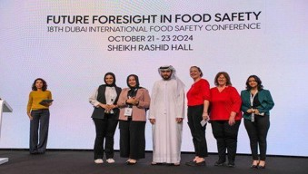
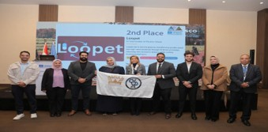
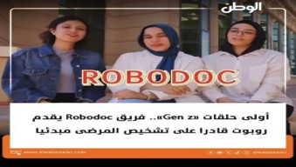
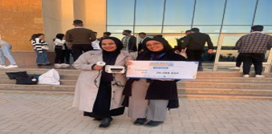
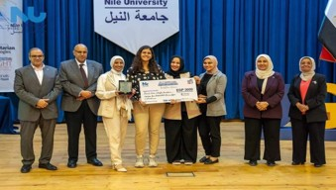
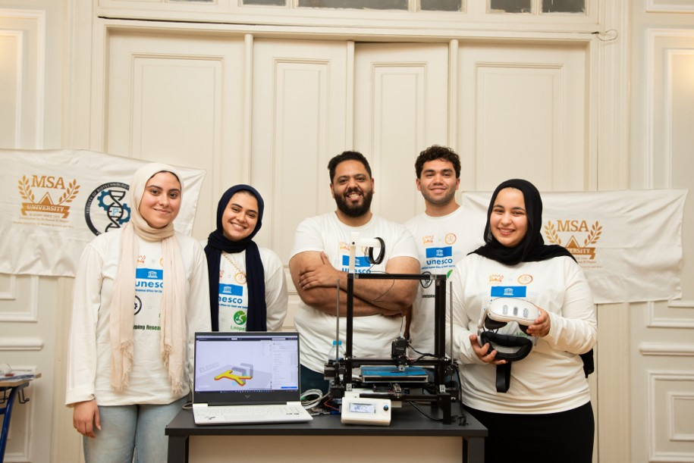
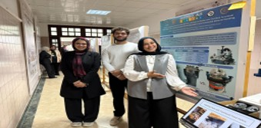
2nd place Poster Award
UNESCO Competition
Smart industry Hackathon

Certificate
Genz Competition
Community outreach
UFRG 2025
Dubai Food Safety

Conferences & competition Posters, Certificates, and Academic Research Outputs

Projects

Project tittle | Description + Technical highlights | Results/Figures
DIY Smart Photobioreactor and Chemostat for Automated Microalgae Cultivation | A low-cost, AI-assisted photobioreactor integrating a lens-free microscope, microfluidics, Arduino control, and Faster R-CNN for real-time microalgae monitoring, automated detection, and optimized cultivation conditions. Technical Highlights:  This system combines AI-based microalgae detection using Faster R-CNN, lens-free microscopy for real-time imaging, and a microfluidic nutrient delivery system to optimize cultivation conditions. The platform is powered by Arduino-based automation and features a modular 3D-printed design, providing an affordable, scalable, and efficient solution for automated microalgae monitoring and bioprocess control. | 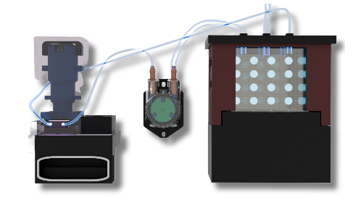  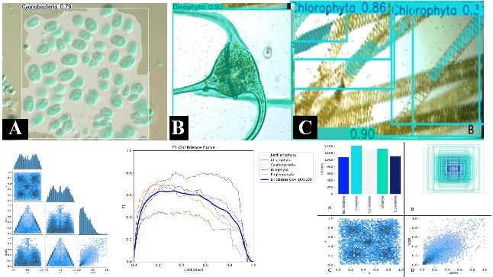
DIY Food 3D Bio-Printer with G-Code-Free Intelligent Slicer | A low-cost food 3D bioprinting platform that combines an AI-powered G-code-free slicer, custom extrusion hardware, and optimized printing parameters to fabricate customizable food structures with improved precision and accessibility. Technical Highlights:  The system integrates an AI-assisted G-code-free slicing algorithm, a custom-designed food extrusion pump nozzle, and a modified 3D bioprinter for precise food deposition. It supports real-time optimization of printing parameters, including flow rate, speed, and extrusion consistency, while enabling the fabrication of customized food structures with enhanced accuracy, repeatability, and ease of use. | 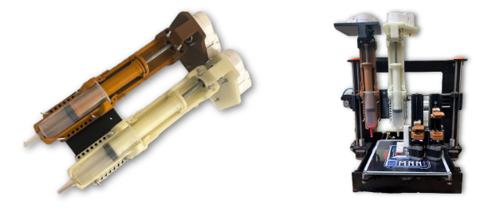  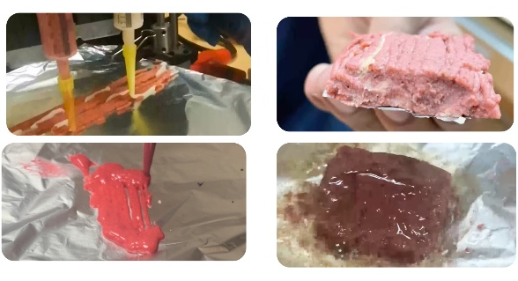
Production of Nisin-Conjugated CuO Nanoparticles for Enhanced Natural Food Preservation | A sustainable food preservation approach that combines the natural antimicrobial peptide nisin with copper oxide nanoparticles (CuO-NPs) to enhance antibacterial activity, extend food shelf life, and provide an eco-friendly alternative to conventional preservatives.  Technical Highlights:  The system integrates green synthesis of CuO nanoparticles, nisin conjugation, and antimicrobial evaluation to enhance bactericidal activity against foodborne pathogens. The approach improves preservative performance while supporting sustainable, natural, and scalable food preservation solutions. | 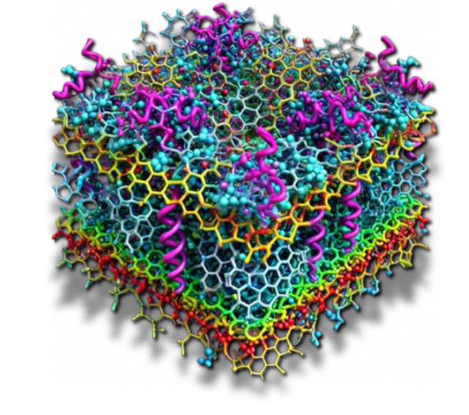  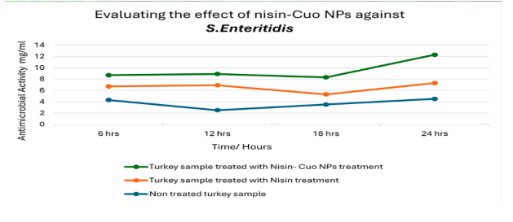
Development of 3D Bioprinted Scaffolds for Liver Tissue Engineering Using PVA Filaments and FDM 3D Printing | A cost-effective tissue engineering platform that utilizes FDM 3D printing and PVA filaments to fabricate biocompatible liver scaffolds, providing structural support for cell growth and advancing regenerative medicine research.  Technical Highlights:  The platform combines FDM 3D printing, PVA-based scaffold fabrication, and optimized scaffold design to produce porous, biocompatible structures for liver tissue engineering. It supports cell attachment, controlled biodegradability, and cost-effective scaffold manufacturing for regenerative medicine applications. | 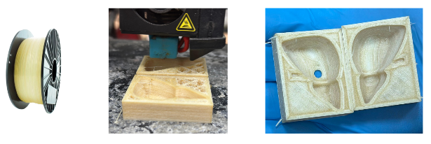  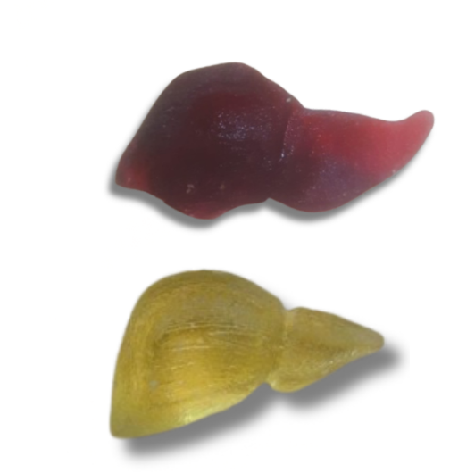
PsychoNova: Gamified Interventions and Wearable EEG Integration for Anxiety Modulation | An AI-powered mental health platform that combines wearable EEG, physiological sensors, and immersive VR therapy to monitor stress in real time and deliver personalized interventions for anxiety reduction and emotional well-being.  Technical Highlights:  The system integrates wearable EEG, GSR and physiological sensing, VR-based gamified therapy, and AI-driven data analysis to monitor emotional states and provide real-time neurofeedback. It enables personalized anxiety management through adaptive interventions and objective physiological assessment. | 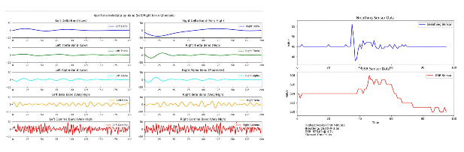  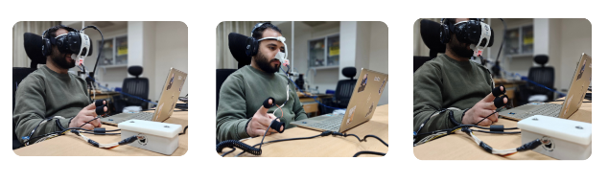
RoboDoc: AI-Powered Humanoid Healthcare Assistant for Smart Hospitals | An AI-powered humanoid robot that assists doctors and hospital staff through intelligent patient interaction, clinical support, and smart hospital automation. The project received EGP 500,000 in funding for its innovation and impact.  Technical Highlights:  The system combines AI-powered interaction, computer vision, voice communication, and autonomous navigation to support patient care and improve hospital workflow efficiency. | 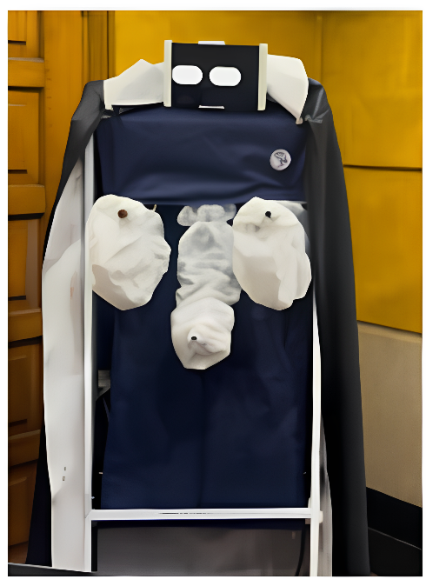
RoboDoc Smart Diagnostic Arm for AI-Based Patient Screening | A compact robotic diagnostic arm designed to support the RoboDoc platform by performing automated patient screening using AI, computer vision, and integrated medical sensors. The system enables rapid, non-invasive preliminary health assessments in healthcare environments.  Technical Highlights: The system combines computer vision, AI-assisted disease screening, multi-sensor integration, and a servo-controlled robotic arm to perform real-time patient assessment. Its modular and portable design enables accurate, contactless screening while supporting efficient clinical workflows. | 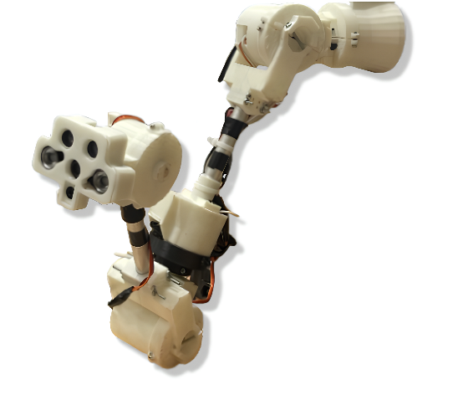
Humanoid RoboDoc: An AI-Driven Humanoid Robot for Patient Diagnosis and Care Assistance | An AI-powered humanoid healthcare assistant designed to support patient diagnosis, monitoring, and interaction through intelligent vision, voice communication, and autonomous decision support, enhancing healthcare accessibility and clinical efficiency.  Technical Highlights:  The system integrates computer vision, AI-based medical decision support, natural language processing, and real-time patient interaction within a humanoid robotic platform. It combines sensor-based health monitoring, autonomous navigation, and human–robot interaction to assist healthcare professionals with patient assessment, routine clinical tasks, and personalized care delivery while improving workflow efficiency and patient engagement. | 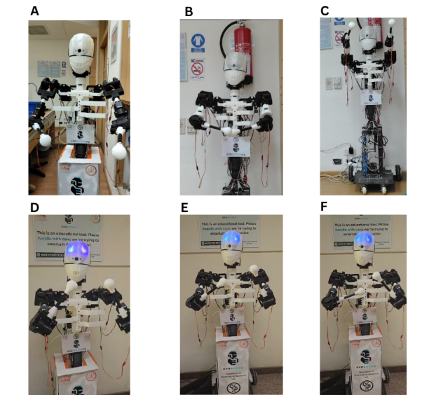
Loopet: Autonomous Bioconversion of Poultry Waste into Certified Functional Feed Using an AI-Controlled Thermal Processing System and Automated Material Handling | An AI-driven waste valorization platform that converts poultry waste into high-quality functional animal feed through intelligent thermal processing, automated material handling, and real-time process optimization, promoting sustainable and circular bioeconomy practices.  Technical Highlights: The system integrates AI-controlled thermal processing, automated material handling, and smart process monitoring to optimize poultry waste conversion into high-quality functional feed. Its modular design enhances production efficiency, feed consistency, and sustainability for scalable bioeconomy applications. | 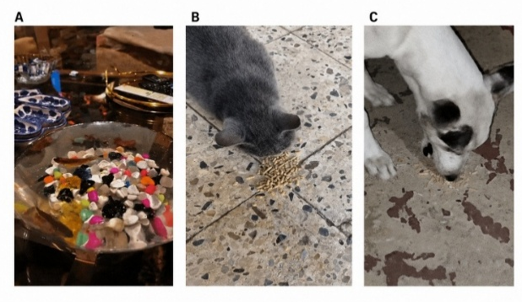  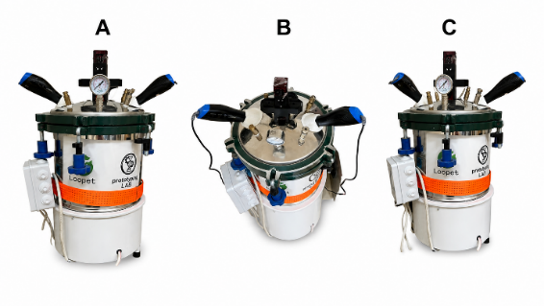
RoboDoc: AI-Powered Diagnosis of Oral Diseases and Comprehensive Oral Health Assessment | An AI-powered diagnostic system that enables rapid and accurate oral disease detection through computer vision and deep learning, providing real-time oral health assessment to improve accessibility and support clinical decision-making.  Technical Highlights:  The system combines deep learning-based image analysis, computer vision, and a portable imaging device for real-time oral disease diagnosis. It delivers high-accuracy detection, automated screening, and comprehensive oral health assessment in an accessible and user-friendly platform. | 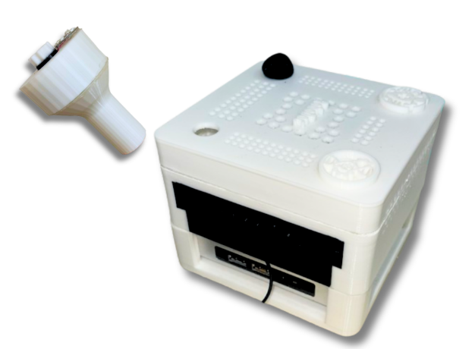
Pollibotics –  Co-founder & Developer (Smart Vertical Farm System) | Co-founded and developed an autonomous wheeled vertical farming robotic system designed for plant-level monitoring and targeted intervention. The platform integrates machine vision, environmental sensing, and robotic mobility to detect plant stress, irrigation requirements, and early disease symptoms. The system performs localized irrigation and pesticide application using onboard pumps and provides real-time decision support & feedback to farmers through a connected application, supporting data-driven and precision greenhouse management. Field tested and system validated in real agricultural environments  Technical Highlights:  Mechanical design, CNN-based plant disease detection, environmental sensing (temperature, humidity), autonomous navigation, embedded systems, IoT communication, real-time decision support. | 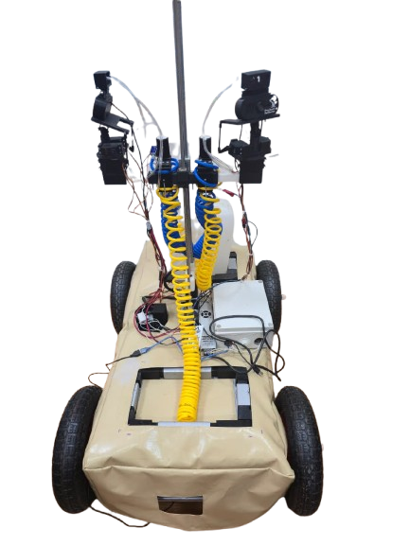
Evobotics –  Co-founder & Developer  (Biped Walking Robot) | Co-developed a compact bipedal robotic platform with a custom low-cost walking mechanism. Led mechanical design, CAD modeling, and 3D printing, as well as programming of motion control and gait stability. The system demonstrated cost-efficient locomotion and adaptive walking performance.  Technical Highlights:  Kinematic design, motion control, stability optimization, Python programming. | 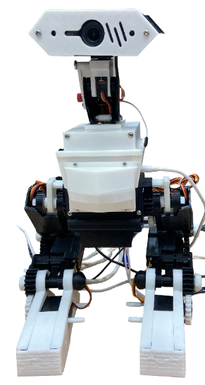
Evobotics –  Co-founder & Developer  (Genomic-Based Interactive Robot) | Co-developed an adaptive wheeled robotic platform integrating articulated mechanisms and speech interaction. Led system design, 3D printing, and development of a genomic-inspired behavioral framework in which algorithmic “genetic mutations” dynamically modify robot responses. The project explored adaptive control, human–robot interaction, and cost-effective implementation of intelligent behavior.  Technical Highlights:  Embedded systems, adaptive behavioral algorithms, robotic interaction, speech modules, real-time control architecture. | 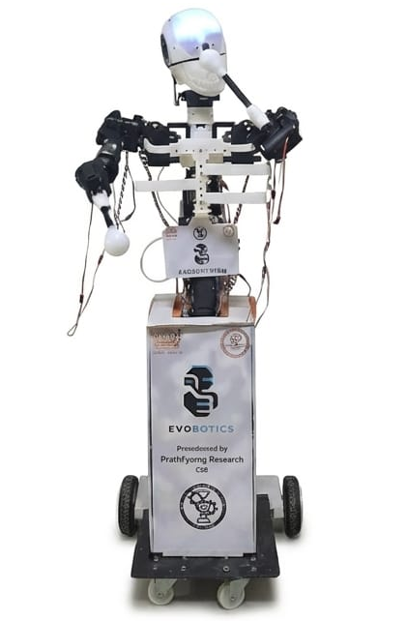
Evobotics –  Co-founder & Developer  (Educational Interactive Robot) | Co-developed an educational robotic platform designed to engage children through interactive learning activities on a connected tablet. Led the design of movement mechanisms, 3D modeling and printing of structural components, as well as motor integration, robot programming, and development of the interactive learning platform. The system enabled real-time interaction between the robot and users, enhancing engagement through responsive educational experiences.  Technical Highlights:  Mechanical design, CAD modeling, 3D printing, motor control, embedded programming, human–robot interaction, educational technology. | 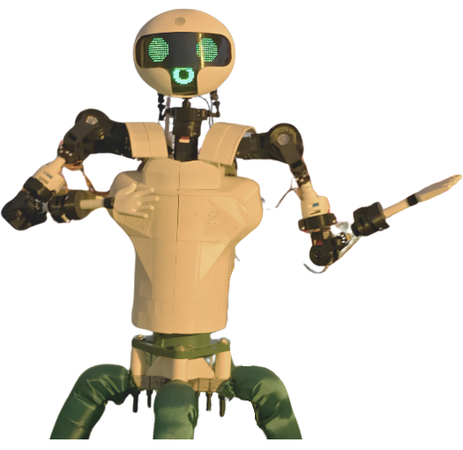
Community Impact & Technical Outreach | Organized community outreach programs and technical workshops to promote STEM education, sustainability, and innovation through hands-on experiences in AI, robotics, and 3D printing.  Technical Highlights:  Conducted STEM outreach, robotics and AI demonstrations, 3D printing workshops, and technical training sessions in collaboration with UNESCO and MSA University. | 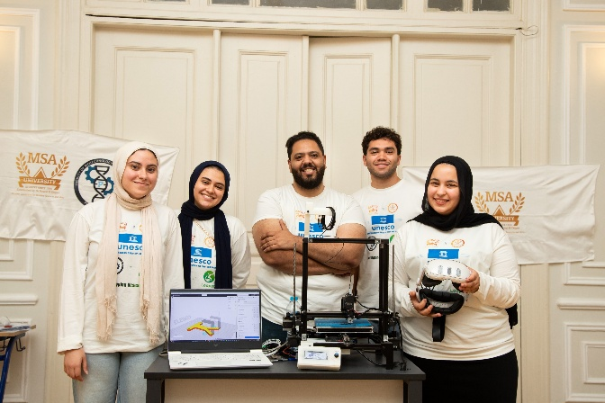

Posters presented in Competitions & Conferences

Posters | Titles | Presented at
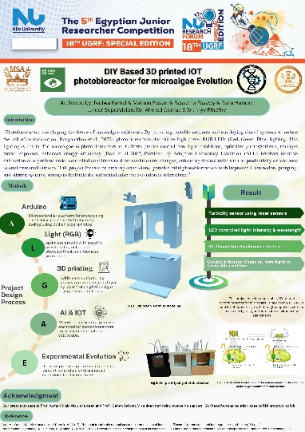 | DIY Based 3D printed IOT Photobioreactor for microalgae Evolution | UGRF Nile University
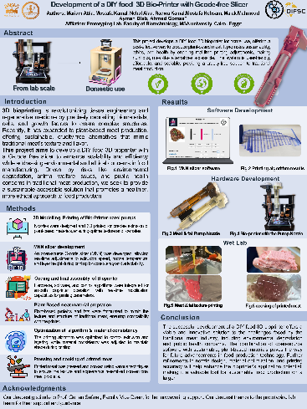 | Development of a DIY Food 3D Bio-Printer with G-code free Slicer | 18th Dubai Internation Food Safety Conference (Exhibited in Dubai)
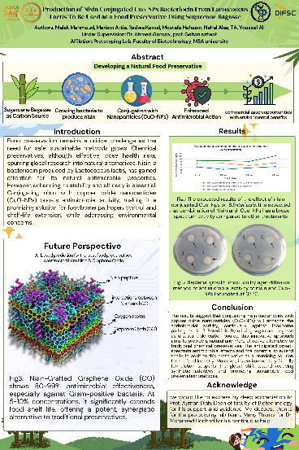 | Fabrication of Nisin Conjugated Cuo-NPs Bacteriocin From Lactococcus lactis to be Used as a Food Preservative using Sugarcane Bagasse
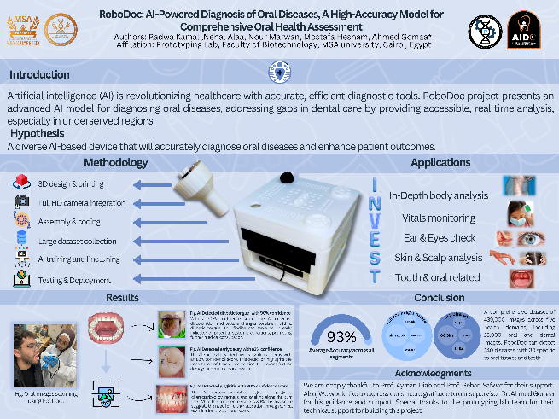 | RoboDoc: AI-Powered Diagnosis of Oral Diseases; a High Accuracy Model for Comprehensive Oral Health Assessment |  | Al-Azhar Global Dental Competition (AGDC 2025)
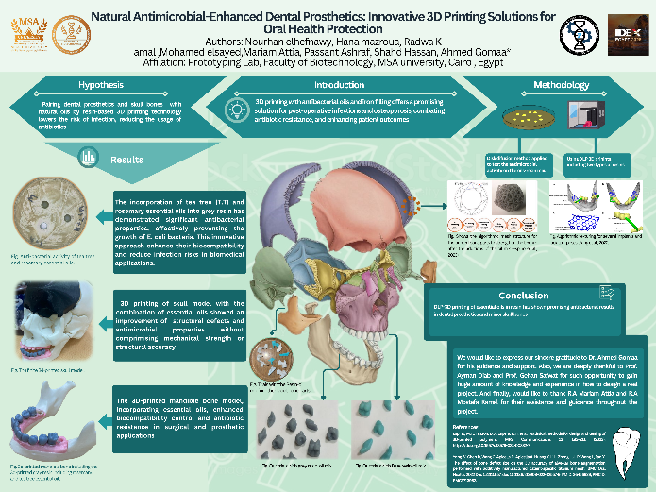 | Natural Antimicrobial-Enhanced Dental Prosthetics: Innovative 3D Printing Solutions for Oral HealtProtection |  | Al-Azhar Global Dental Competition (AGDC 2025)
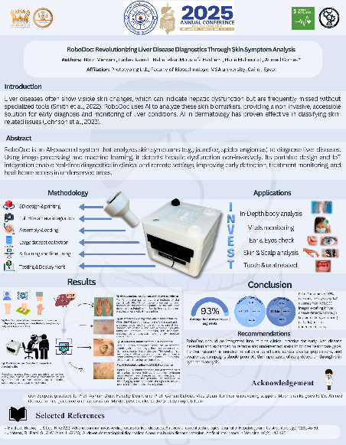 | RoboDoc: Revolutionizing Liver Disease Diagnostics Through Skin Symptom Analysis | Theodor Bilharz Annual Conference (2025)
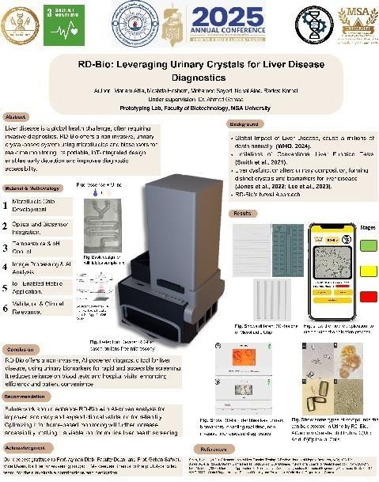 | RD-Bio: Leveraging Urinary Crystals for Liver Disease Diagnostics
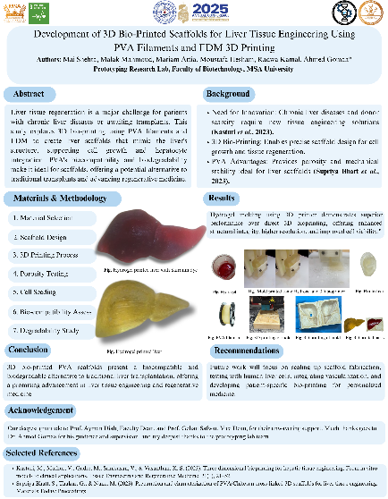 | Development of 3D Bio-Printed Scaffolds for Liver Tissue Engineering Using PVA Filaments and FDM 3D Printing
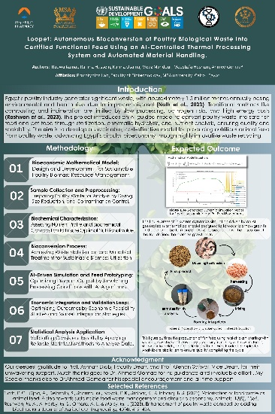 | Loopet: Autonomous Bioconversion of Poultry Biological Waste into Certified Functional Feed Using an AI-Controlled Thermal Processing System and Automated Material Handling. | Industrial Discussion Faculty of Biotechnology , MSA University
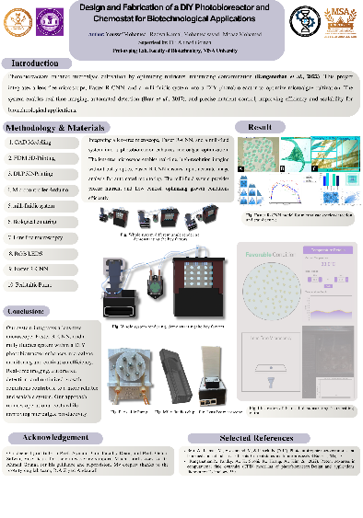 | Design and Fabrication of a DIY Photobioreactor and Chemostat for Biotechnological Applications | Scientific Poster, SOLE Season 11
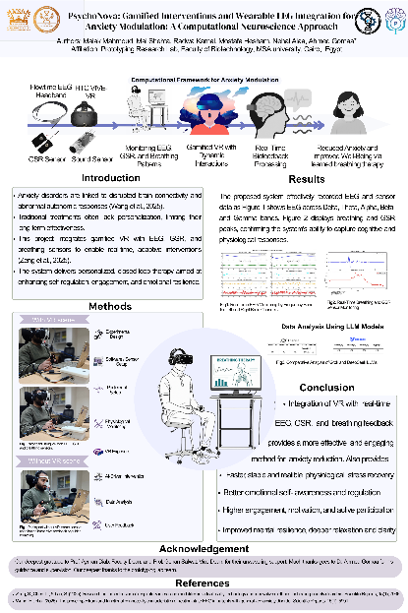 | PsychoNova: Gamified Interventions and Wearable EEG Integration for Anxiety Modulation: A Computational Neuroscience Approach | the World Psychiatric Association (WPA) Conference in Alexandria, Egypt.
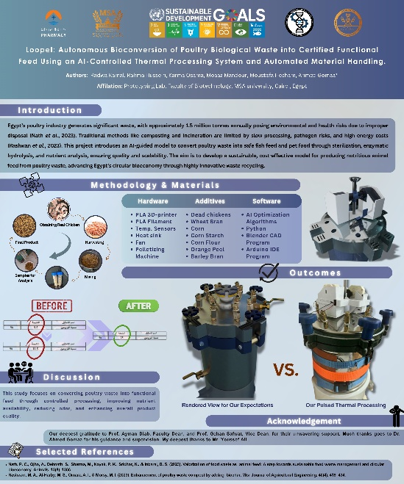 | Loopet: Autonomous Bioconversion of Poultry Biological Waste into Certified Functional Feed Using an AI-Controlled Thermal Processing System and Automated Material Handling. | 3rd International Conference, Faculty of Pharmacy at October 6 University

Publications:

Alaa, N., Hesham, M., Attia, M., Kamal, Radwa, Alhammad, S. A. S., Ibrahim, D., Safwat, G., Diab, A. A., & Gomaa, A. E. (2025). The Role of Agentic AI in Revolutionizing Biotechnology: An Overview. International Journal for Biotech Research and Innovations (IJBRI), Inaugural Issue. Faculty of Biotechnology, MSA University. Published: 25 December 2025.

Startups

PolliBotics

- CFO July 2025 – Present
- Agri-biotechnology startup focused on innovative agricultural technologies.
- Signed a cooperation agreement with Cultivech, a leading company specializing in commercial hydroponic systems.
- Laboratory Host: Prototyping Research Lab, Faculty of Biotechnology, MSA University.

EduBotics
- Co-founder 2026 – Present
- Educational technology startup focused on integrating robotics and artificial intelligence into STEM education.
- Laboratory Host: Prototyping Research Lab, Faculty of Biotechnology, MSA University.

Technical Skills

Biotechnology & Laboratory Techniques
- Molecular genetics, microbiology, biochemistry, plant and animal cell & tissue culture
Programming & AI
- Languages & Frameworks: R, Arduino, Python (Programming), Flutter (mobile interface development)
- AI & Computer Vision: Machine learning (scikit-learn, pandas, Numpy, Matplotlib), deep learning (TensorFlow, Keras, PyTorch, TorchVision), Computer vision (OpenCV, Pillow, YOLO), Model Training (HPC, Jupyter Notebook, Google Colab)
- Coding platforms: Cursor (GPT-3.5, GPT-4, GPT-4o, Claude 3 Opus), Antigravity (Claude 3.5 Sonnet, Claude 3 Opus, Gemini Flash,), Grok (Grok-1, Grok-1.5, Grok-2), Visual Studio Code (CLINE), Claude (Claude 2, Claude 3 Opus, Claude 3 Sonnet, Claude 3 Haiku, Claude 3.5 Sonnet)

Embedded Systems
- Microcontrollers & Hardware: Arduino Uno, Mega, Nano, Mini, Due, Pro/Portenta H7, ESP series (Wi-Fi & BLE)
- SBC Platforms: Raspberry PI 3,4,&5, System setup, software configuration, and hardware interfacing
- Motors: DC & AC motors, servos, stepper motors; motor control programming
- Sensors & Integration: Temperature, humidity, RGB, LIDAR, wireless sensors; sensor calibration, integration, and programming
- OS: Windows, Linux (Ubuntu, Ubuntu server, Raspbian)
- Autonomous Systems: Development of wheeled and vertical farming robotic systems, real-time sensor-based navigation
CAD Modelling & 3D Printing:
- CAD & Modeling: Blender (mechanical and robotic system modeling & CFD simulations)
- 3D Printing & Fabrication: FDM and DLP printing, Cura slicing, and G-Code optimization
High-Performance Computing (HPC) & Data Processing
- HPC Setup: I work with Parallel computing for AI model training and large-scale simulations, our current facility is multi-node cluster with 4× NVIDIA RTX 5000 Ada GPUs per node (32 GB GDDR6 ECC), 256 GB DDR4 ECC RAM
- Project: LLM AI model training 7-15b Parameter, simulation of robotics and autonomous systems, data-heavy computation pipelines for epidemic forecasting
Languages
- Arabic (Native), English (C1), French (Beginner).

Volunteering & Activities

- Volunteer - FA Model, MSA University, Cairo, Egypt.

  - Simulated the operations of the Food and Agriculture Organization of the United Nations (FAO), leading discussions and coordinating team activities.

- Volunteer - Videos Making Member – Red Heart, Cairo, Egypt.

- Contributed to producing awareness and promotional video content in support of the organization's initiatives.

- Volunteer - Lebaladna Charity and Development Foundation, Cairo, Egypt.

  - Supported charitable and developmental programs, contributing to the foundation's community outreach efforts.

- Active Member – Institute of Electrical and Electronics Engineers (IEEE), MSA University, Cairo, Egypt.

  - Participated in club activities and events, strengthening technical knowledge and teamwork skills.

- Volunteer – Model World Health Organization (MWHO), Cairo, Egypt.

  - Simulated the operations of the World Health Organization, engaging in policy discussions and diplomatic negotiation.
Academic Advisors & Referees:

Name | Dr. Ahmed Gomaa | Prof. Ayman Diab
Affiliation | Assistant Professor of Synthetic Biology & PI of the Prototyping Lab at the Faculty of Biotechnology, MSA University. | Dean of the Faculty of Biotechnology & Head of the RDI (Research, Development, and Innovation) Group at the faculty of biotechnology at MSA University.
Lab website | www.gomaaprototype.com
Lab LinkedIn link | https://www.linkedin.com/company/prototyping-lab-rdi-msa-uni/posts/?feedView=all
E-mail | aigomaa@msa.edu.eg | adiab@msa.edu.eg
Mobile Number | +20-1063701168 | +20-1222298487
LinkedIn profile | https://www.linkedin.com/in/ahmed-gomaa-ph-d-8a7b77135/ | https://www.linkedin.com/in/prof-ayman-diab-b4849617/

